**LAB REPORT 07**

**University of Engineering and Technology Peshawar**



**Digital Logic Design**

Submitted by: **Maaz Habib**

Registration number: **20PWCSE1952**

Section: **C**

Batch: **22**

Submitted to: **Engr. Faiz Ullah**

## **Objectives:**

## After completing this experiment, you will be able to:

## ▪ Design and construct Multiplexer and De Multiplexer

## ▪ Verify their truth tables using basic logic gates

## **Components Required:**

## ▪ Two 7411, 3 I/P AND gates

## ▪ 7432, 2 I/P OR gate

## ▪ 7404, hex inverter

## **Multiplexer:**

Multiplexing is the generic term used to describe the operation of sending one or more analogue or digital signals over a common transmission line at different times or speeds and as such, the device we use to do just that is called a **Multiplexer**.

The multiplexer, shortened to “MUX” is a combinational logic circuit designed to switch one of several input lines through to a single common output line by the application of a control signal. Multiplexers operate like very fast acting multiple position rotary switches connecting or controlling multiple input lines called “channels” one at a time to the output.

Multiplexers, or MUX’s, can be either digital circuits made from high speed logic gates used to switch digital or binary data or they can be analogue types using transistors, or relays to switch one of the voltage or current inputs through to a single output.

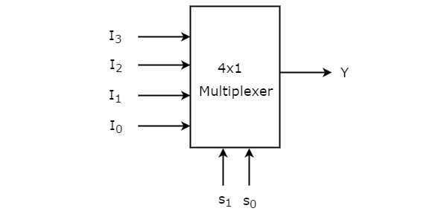

### **Understanding 4-to-1 Multiplexer:**

The 4-to-1 multiplexer has 4 input bits, 2 control or select bits, and 1 output bit. The four input bits are D0,D1,D2 and D3. Only one of this is transmitted to the output Y. The output depends on the values of A and B, which are the control inputs. The control input determines which of the input data bit is transmitted to the output.

For instance, as shown in figure, when A B = 0 0 , the upper AND gate is enabled, while all other AND gates are disabled. Therefore, data bit D0 is transmitted to the output, giving Y = Do.

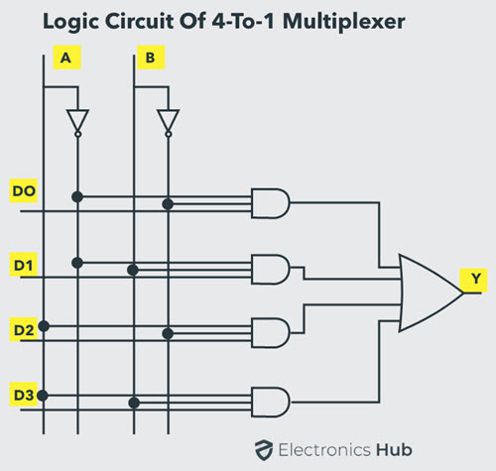

|  |  |  |
| --- | --- | --- |
| S1 | S0 | Y=output |
| 0 | 0 | D0 |
| 0 | 1 | D1 |
| 1 | 0 | D2 |
| 1 | 1 | D3 |

If the control input is changed to A B = 1 1, all gates are disabled except the bottom AND gate. In this case, D3 is transmitted to the output and Y = D3.

* An example of 4-to-1 multiplexer is IC 74153 in which the output is same as the input.
* Another example of 4-to-1 multiplexer is 45352 in which the output is the compliment of the input.
* Example of 16-to-1 line multiplexer is IC 74150.

### **Applications of Multiplexer**

Multiplexer are used in various fields where multiple data need to be transmitted using a single line. Following are some of the applications of multiplexers –

1. **Communication System** – Communication system is a set of system that enable communication like transmission system, relay and tributary station, and communication network. The efficiency of communication system can be increased considerably using multiplexer. Multiplexer allow the process of transmitting different type of data such as audio, video at the same time using a single transmission line.
2. **Telephone Network** – In telephone network, multiple audio signals are integrated on a single line for transmission with the help of multiplexers. In this way, multiple audio signals can be isolated and eventually, the desire audio signals reach the intended recipients.

**FUNCTION TABLE:**

|  |  |  |
| --- | --- | --- |
| **S1** | **S0** | **Output Y** |
| **0** | **0** | D2 → D2 S1’ S0’ |
| **0** | **1** | D1 → D1 S1’ S0 |
| **1** | **0** | D3 → D3 S1 S0’ |
| **1** | **1** | D0 → D0 S1 S0 |

**EQUATION:**

Y = D2 S1’ S0’ + D1 S1’ S0 + D3 S1 S0’ + D0 S1 S0

Real time circuit:

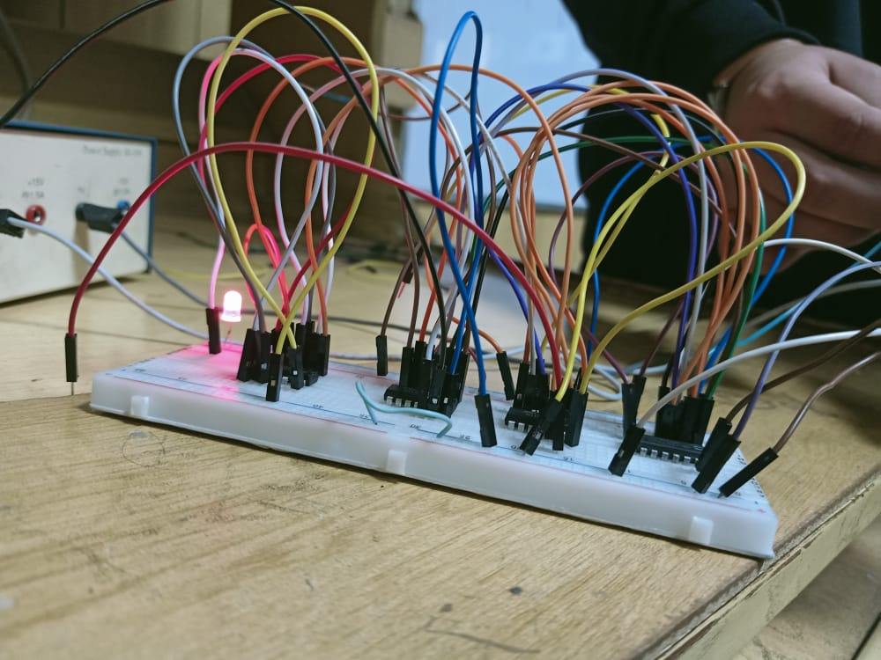

## **Demultiplexer**

Demultiplexer means one to many. A demultiplexer is a circuit with one input and many outputs. By applying control signal, we can steer any input to the output. Few types of demultiplexer are 1-to 2, 1-to-4, 1-to-8 and 1-to 16 demultiplexer.

Following figure illustrate the general idea of a demultiplexer with 1 input signal, m control signals, and n output signals.

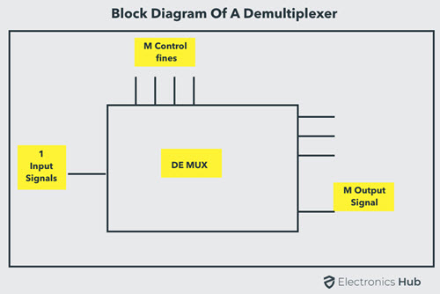

### **Understanding 1-to-4 Demultiplexer**

The 1-to-4 demultiplexer has 1 input bit, 2 control or select bits, and 4 output bits. An example of 1-to-4 demultiplexer is IC 74155. The 1-to-4 demultiplexer is shown in figure below-

0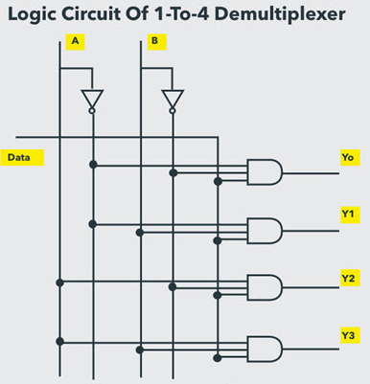

The input bit is labelled as Data D. This data bit is transmitted to the selected output lines, which depends on the values of A and B, the control or Select Inputs.

When A B = 0 1 , the second AND gate from the top is enabled while other AND gates are disabled. Therefore, data bit D is transmitted to the output Y1, giving Y1 = Data.

If D is LOW, Y1 is LOW. If D is HIGH, Y1 is HIGH. The value of Y1 depends upon the value of D. All other outputs are in low state.

If the control input is changed to A B = 1 0 , all the gates are disabled except the third AND gate from the top. Then, D is transmitted only to the Y2 output, and Y2 = Data.

Example of 1-to-16 demultiplexer is IC 74154. It has 1 input bit, 4 control / select bits and 16 output bit.

**FUNCTION TABLE:**

|  |  |  |
| --- | --- | --- |
| **S1** | **S0** | **Output Y** |
| **0** | **0** | X=D2 → X S1’ S0’ |
| **0** | **1** | X=D1 → X S1’ S0 |
| **1** | **0** | X=D2 → X S1 S0’ |
| **1** | **1** | X=D3 → X S1 S0 |

### **Applications of Demultiplexer**

**Communication System**

Communication system use multiplexer to carry multiple data like audio, video and other form of data using a single line for transmission. This process make the transmission easier. The demultiplexer receive the output signals of the multiplexer and converts them back to the original form of the data at the receiving end. The multiplexer and demultiplexer work together to carry out the process of transmission and reception of data in communication system.

**QUESTIONS:**

**QUESTION 01:**

## **Difference Between Multiplexer and Demultiplexer**

|  |  |  |
| --- | --- | --- |
| **Parameters** | **Multiplexer** | **Demultiplexer** |
| Definition | Multiplexer refers to a type of combinational circuit that accepts multiple inputs of data but provides only a single output. | The demultiplexer refers to the type of combinational circuit that accepts just a single input but directs it through multiple outputs. |
| Technique of Conversion | A Multiplexer performs conversion from parallel to serial. | A Demultiplexer performs conversion from serial to parallel. |
| Common Name | Data Selector | Data Distributor |
| Operational Principle | Multiplexer works on an operational principle of many to one. | Demultiplexer works on an operational principle of one to many. |
| Configuration of Devices | It behaves as a data selector because the multiplexer is an N to 1 device. | It behaves as a data distributor because the demultiplexer is a 1 to N device. |
| Total Number of Data Inputs | It has multiple inputs of data and signals. | It has a single input of data and signals. |
| Total Number of Data Outputs | A Multiplexer generates a single output for data and signals. | A Demultiplexer generates multiple outputs for data and signals. |
| Information Processing | It processes the digital data and info by collecting them from multiple sources and integrating them into a single source as the output. | It collects digital data and info from one single source/channel and then converts it into a set of multiple sources as the outputs. |
| Type of Digital Setup | The multiplexer acts as a digital switch. | The demultiplexer acts as a digital circuit. |
| Logic Type | A multiplexer follows a logic type that is combinational. | A demultiplexer also follows a combinational logic type. |
| End of Usage | In the process of time-division Multiplexing, we use a Multiplexer at the end of the transmitter. | In the process of time-division Multiplexing, we use a Demultiplexer at the end of the receiver. |

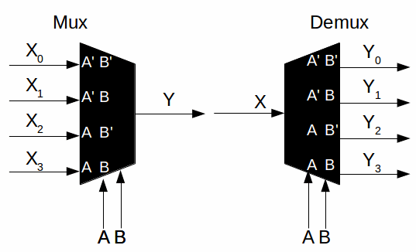

**QUESTION 02:**

